Using Salute for Math Fact Fluency:
- Derived Fact Strategy Game for Addition and Subtraction
- Targeted facts: Sums and differences within 20
- Addition is generally easier than subtraction for many students.
- An excellent way to practice the Think Addition strategy is through the game Salute.
- Think Addition is an effective strategy in which students approach learning subtraction facts by thinking of related addition facts.
- One way to help students see the connection between known addition facts and subtraction facts is to practice generating “fact families” starting with the subtraction fact and inviting students to offer the related addition facts.
- Recording the fact families as students play reinforces the connection between addition and subtraction.
About Games and Math Fact Fluency:
Games are fun. But, more importantly, games are effective ways to support learning. Games provide opportunities for:
- low-stress practice of (1) facts and (2) strategies (both outcomes are critical to math beyond the basic facts!).
- think aloud, an effective learning strategy. Therefore, students should develop the habit of verbalizing their mathematical thinking out loud.
- student listening and learning from peers. Therefore, discussing strategies before and after playing allows students opportunities to learn from each other.
- teachers to formatively assess and plan instruction. Therefore, at times, use an observation tool to record how students are progressing.
Effective math fact fluency games remove time pressure and allow students time to think. That means no time component. Each player has their own cards or dice to roll, so they are not racing each other. Scoring is de-emphasized. Thinking strategies are front and center.
Salute 3 players
Materials: Deck of ten frame cards, numeral cards, or playing cards with numbers 0–10 (ace = 1, queen = 0; remove other face cards), student recording sheet (see below).

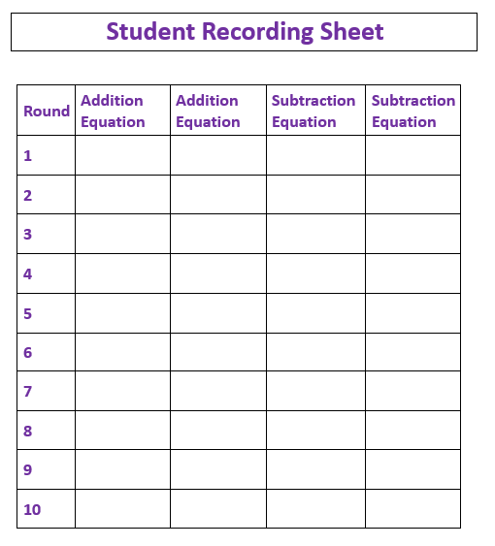
Salute 3 players
How to Play:
- Determine which of the three students will be the leader for the first draw.
- This player takes the deck (face down) and hands each of the other two players a card.
- Without looking at the card they were handed, the two players place their card on their forehead facing outward (so the others can see it).
- The leader says the sum of the two cards.
- The other two players determine the value of the card on their forehead, based on hearing the sum and seeing the card on the other player’s forehead (one addend).
- Both players share how they determined their number.
- If using the player recording sheet, players record the four related facts for their numbers.
- The player who was first to answer, keeps the cards.
- The player to the right of the leader becomes the leader for the next round.
- Play continues until the deck is gone or time is up.
I must have a 4! I know that because you have a 6 and 6 + 4 equals 10!
Game in Action:
The sum of the two cards equals 10.

This Photo by Unknown Author is licensed under CC BY-SA

Possible Variations:
- Use only a select group of cards, such as numbers 1-5.
- Include a fourth player. The leader now finds the sum of three cards, and the players must determine their cards by finding the difference between the sum of all three and the sum of the other two.
- Multiply to find the product instead of the sum. The other two players must determine the factor on their forehead.

